HOTEL RESERVATION FORM
会议住宿协议接待酒店

Guest General Information客人信息
Personal detail (客人信息)
Last Name（姓）: | Middle Name: |  | First Name(名):
Nationality（国籍）: |  | Telephone（电话）:
E-mail（邮箱）: |  | Passport No. (护照号)：
Reservation detail(预订信息)
Check-in Date（dd-mm-yy）：  入住日期 |  | Check-out Date（dd-mm-yy）：  退房日期
Room Type（房型）:
Conference Hotel Twin Room (会议酒店双床房) □1 breakfast □2 breakfasts
Hot Spring Hotel Twin Room (温泉酒店双床房) □1 breakfast □2 breakfasts
Number of Rooms（房间数）：
Remarks (备注) :

Hotel Information酒店信息
Hotel Name (酒店) | Social Hill International Conference Center Hotel  社会山国际会议中心酒店
Room Type (房型) | Conference Special Rate (协议价/早餐)
Conference Hotel Twin Room (会议酒店双床房) | CNY 398 net including 1 breakfast  CNY448 net including 2 breakfast
Hot Spring Hotel Twin Room（温泉酒店双床房） | CNY340 net including 2 breakfast
Remarks:
- The Conference Hotel is located in the same building as the venue. The Hot Spring Hotel is about 200 m away from the Conference Hotel, and it takes 5 minutes to walk between them.
（会议酒店和会场同在一个楼内。温泉酒店距离会议酒店约200米，步行需要5分钟。）
- The hotel only supports RMB or Visa credit card payments
（酒店仅支持人民币或Visa信用卡支付）
- All bookings are subject to hotel availability and rates are only applicable form 14 July – 19 July 2024.
（所有预订视酒店具体房间情况而定：房价仅适用于2024年7月14日-2024年7月19日）。

Contact person 酒店联系人
Please email above reservation form to Reservations Department
Reservations Department  （预订部） | MP/电话：+86 022 5803 8666 | Email/邮箱：reservation@wisepool.com.cn
Hotel Manager（酒店经理）  Ms. Tian（田女士） | MP/电话：+86 13512882489

Hotel Map 酒店地图
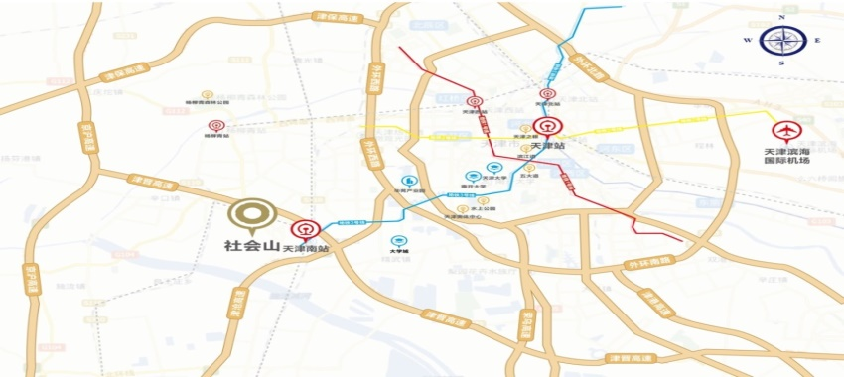
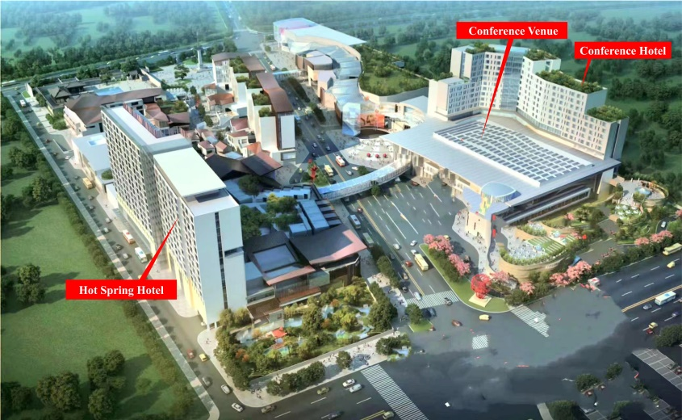
Hotel room category 酒店房型
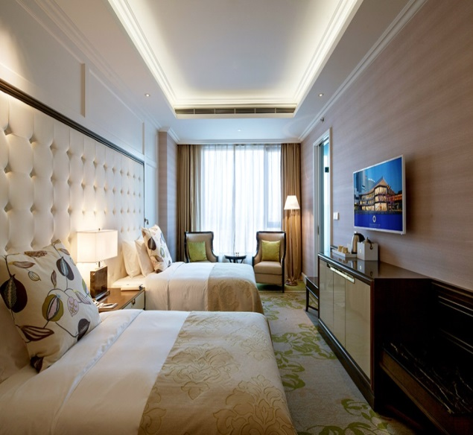
Conference Hotel Twin Room(会议酒店双床房) 40㎡
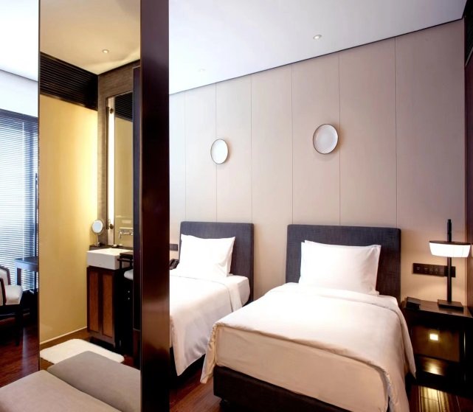
Hot Spring Hotel Twin Room（温泉酒店双床房）40㎡

